V3 Dev Build Instructions

UNJSPF CoDev

Contents
1. Accessing Workspace 2
2. Accessing Instances 2
3. DB Client 3
3.1 DB Instance Details 3
3.2 PL/SQL Developer 3
Setup DB Connection 3
4. GitHub Access 3
5. Checkout, Build and Run 4
5.1 Checkout Code from GitHub 4
5.2 Build 4
5.3 Setup IDE 5
Setup Eclipse 6
Verify Java Version 6
Import Project 7
Create Run/ Debug Configuration 9
5.4 Run UN Application 11
Access the Local Instance 12

1. Accessing Workspace

- Install AWS Client
- Run the AWS Client Application
- Login using the vitechb2c account username and password

2. Accessing Instances
- Open URL https://v3.vitechinc.com/undevwls/app into a chrome browser window to access the Dev instance.
- Credentials: mary/123456

3. DB Client

3.1 DB Instance Details
Sr | Environment | Server Url | DB Name
1 | undevwls | vm-db-un-dev-18c | un_dev_18
2 | unqawls | vm-db-un-dev-18c | Un_qa_18

3.2 PL/SQL Developer

Setup DB Connection
- Select New Database Connection
- Enter DB connection details Database, Username and Password
- Test Connection
- Credentials: dbo/dbo
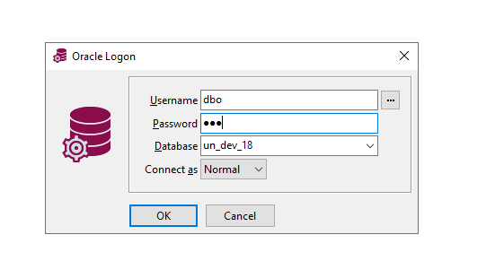

4. GitHub Access
- Verify your GitHub Access by opening the SSO url (https://github.com/enterprises/vitech) in chrome
- If it does not recognize your username, use <username>_vitech and then use the vitechb2c password to log on
- Once you have verified access in chrome also make sure Chrome is your default browser, as we will use the browser login mode to authenticate to GitHub from the command prompt.

5. Checkout, Build and Run

5.1 Checkout Code from GitHub
- Open Git Bash
- Navigate to the directory where the code will be checked out (d:\users\<user>\projects\unjspf)
- Run command "git clone https://github.com/VitechQA/UNJSPF.git unjspf"
- Git may take you to chrome for authentication

- Important Note: The VitechQA branch is being used only for testing GitHub check-in and check-out practices. Once the UN development team is ready, we will create the actual Git branch for development.

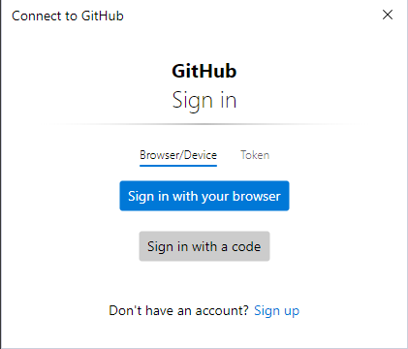
- The code will then be checked out into the subdirectory with name unjspf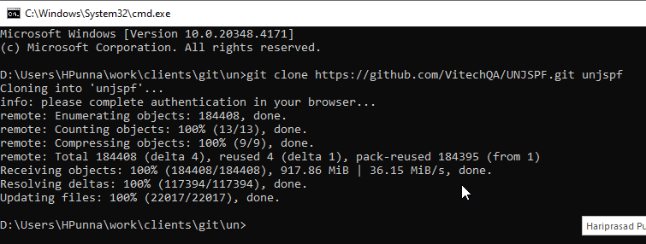

5.2 Build
- Open a command prompt
- Navigate to the folder where the code was checked out (d:\users\<user>\projects\unjspf\unjspf)
- Verify Maven is installed, and the version is 2.2.1.(If the maven version is not available copy from V:\apache-maven-2.2.1)
- Verify Java is installed, and the version is JDK 1.7.(If java version is not available, please reach out to Vitech team)
- We must ensure that same maven and java versions.
Run mvn -version to verify
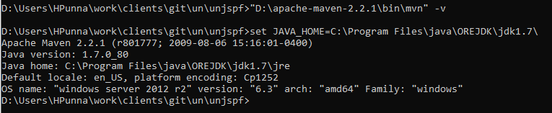

- Run the command below
mvn clean install eclipse:clean eclipse:eclipse
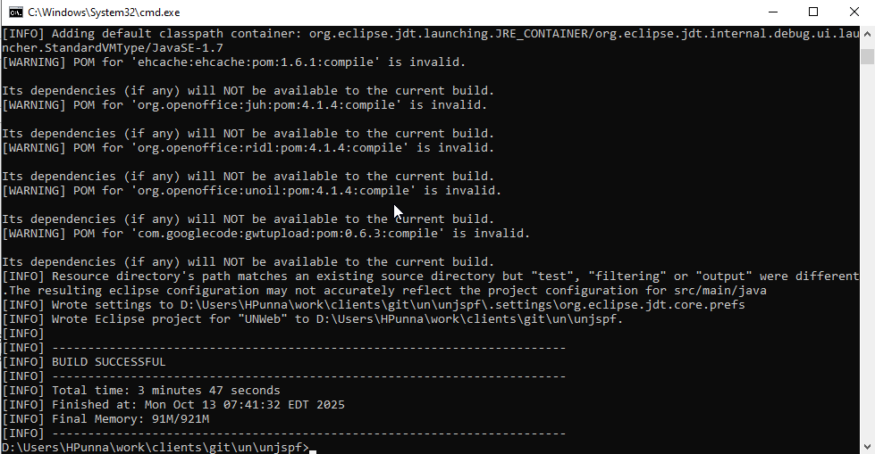

- Verify that the build was successful

5.3 Setup IDE

Setup Eclipse
- Create a new workspace (d:\users\<user>\projects\unjspf)
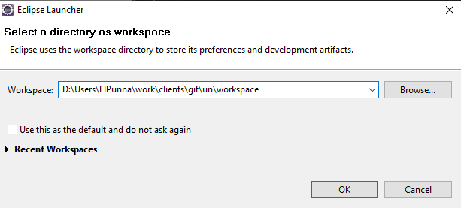

- Click Ok
- Hide the Welcome Screen by clicking on Workbench
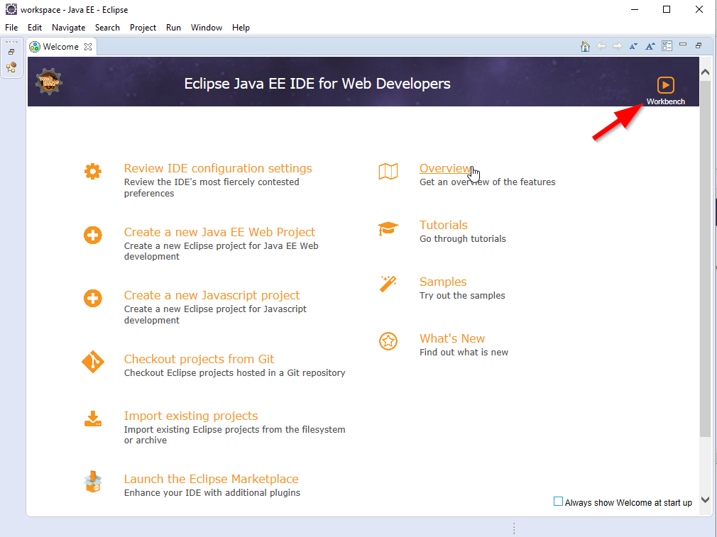

Verify Java Version
- Go to Window > Preferences
- Select Java > Installed JRES
- Verify there is a Java 1.8 available and selected.
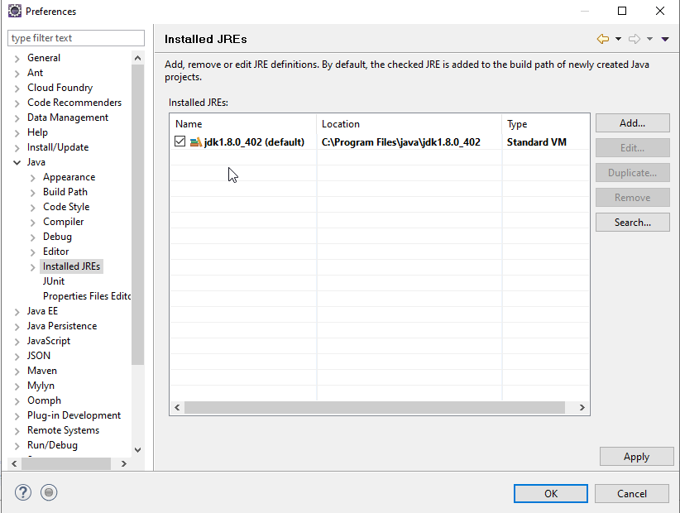

Import Project
- Go to File > Import...
- Select General > Existing Projects into Workspace and Click Next
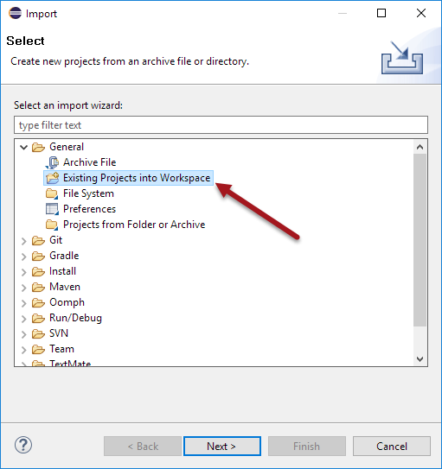
- Select Browse and select the folder where the code was checked out and built and click "Select Folder"
- Click Finish to import the project(s)
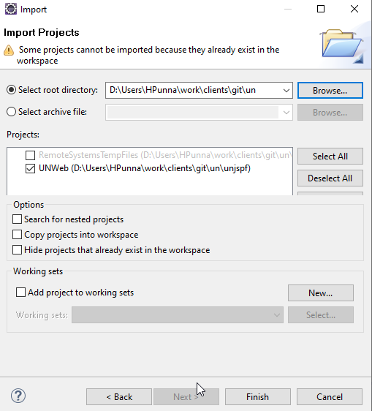

Create Run/ Debug Configuration

Name: UNWeb
Project: UNWeb
Main Class: com.vitechinc.core.util.Launcher
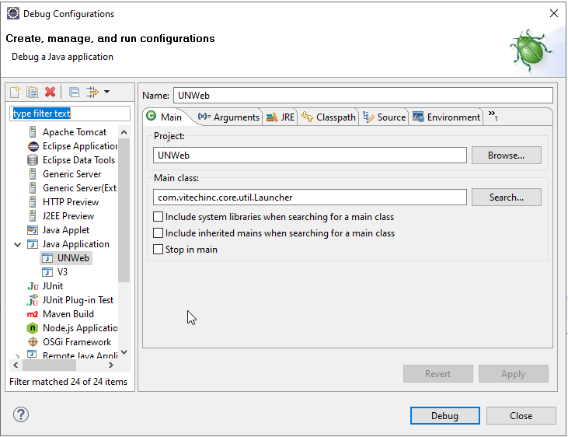

- Setup VM Arguments
-Xms256m
-Xmx1524m
-XX:PermSize=256M
-Dhibernate.show_sql=false
-DstartTimer=true
-Dcom.vitechinc.really-quiet=true
-Dcom.vitechinc.queues.disable-all=true
-Dvitechinc.use-old-exception-page=true
-DDEBUG_MODE=true
-Dorg.apache.tapestry.disable-caching=false
-Dcom.vitechinc.disable-tapestry-precache=false
-Djava.awt.headless=true
-Dinstance.log.postfix=_unqa
-Dcom.vitechinc.v3.disable-JavascriptBlock-signatures=true
-Dcom.vitechinc.v3.un.enable.hr=false
-Dlog4j.debug=true
-Dhibernate.query.startup_check=false
-DOO_MAXTASKS_PP=10
-DOO_TASK_EXEC_TIMEOUT=240000
-DOO_TASK_QUEUE_TIMEOUT=60000
-DOO_PORTNUMBERS=2199,2200,2201

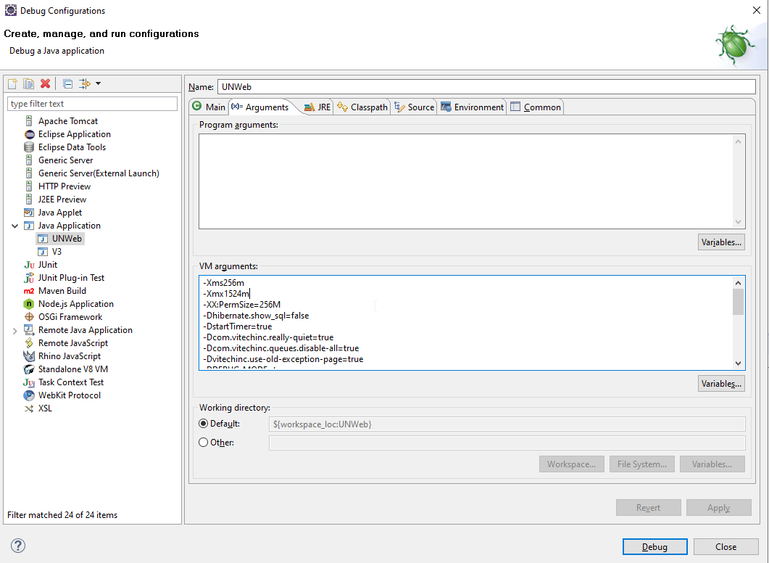

5.4 Run UN Application
- Open instance.properties in the root folder and verify that the connection details are pointing to the database instance you want the local instance to connect to
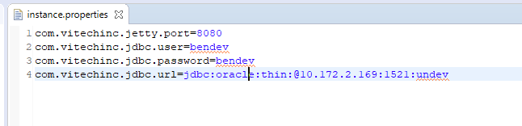
- Select the Debug Dropdown and run the configuration we just created
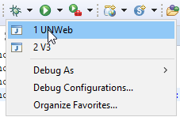

- Wait for the local server to start
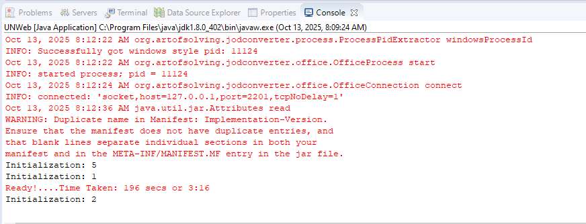

Access the Local Instance
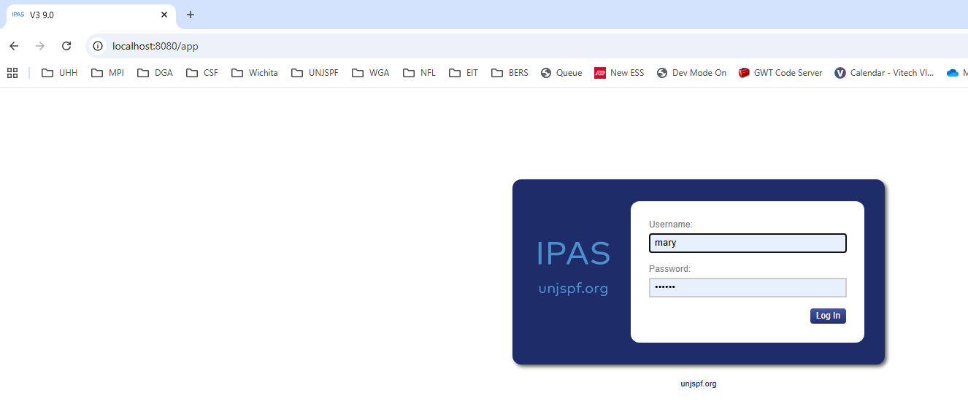
Congratulations!! You have a local instance of V3 running, you can now login with your credentials for the instance this is connected to.

